What is Quality Management System?



A **Quality Management System** (**QMS**) is a collection of business processes focused on consistently meeting customer requirements and enhancing their satisfaction. It is aligned with an organization's purpose and strategic direction (ISO9001:2015). It is expressed as the organizational goals and aspirations, policies, processes, documented information and resources needed to implement and maintain it. Early quality management systems emphasized predictable outcomes of an industrial product production line, using simple statistics and random sampling. By the 20th century, labor inputs were typically the most costly inputs in most industrialized societies, so focus shifted to team cooperation and dynamics, especially the early signaling of problems via a continual improvement cycle. In the 21st century, QMS has tended to converge with sustainability and transparency initiatives, as both investor and customer satisfaction and perceived quality is increasingly tied to these factors. Of QMS regimes, the ISO 9000 family of standards is probably the most widely implemented worldwide – the ISO 19011 audit regime applies to both, and deals with quality and sustainability and their integration.

Where & how can Quality Management System be applied?

A **Quality Management System** (**QMS**) can be applied to any organization, irrespective of size or industry sector. QMS principle approach has following basic principles & strategies in place:

|  |  |
| --- | --- |
| Principles | Strategies |
| * CUSTOMER FOCUS * LEADERSHIP * ENGAGEMENT OF PEOPLE * PROCESS APPROACH * IMPROVEMENT * EVIDENCED BASED APPROACH * RELATIONSHIP MANAGEMENT | * Focus on Customer Satisfaction * Process Approach * Product & Process Quality * PDCA > Plan Do Check Act * Annex SL Model > Frame Work for System Design * The only standard in ISO having Design & Development life cycle for a Product |

What can make Quality Management System journey successful?

To implement & get maximum benefited from QMS, there has to be ***baseline mindset principles***, in which every member of the organization (including Top Management) should believe in:

|  |  |
| --- | --- |
| Mind Set for QMS | Benefits of QMS |
| * The internal System implemented is to use the QMS Principles in the right spirit; * Open mind to adopt culture for new understanding & learning concepts, technology, processes, etc.; * Complete Transparency in understanding, implementing changes, if need be, at appropriate time; * **Always believe that, what we know today is not enough and not the end**; * Always believe in and practice team work, commitment to improve and believe in that: * **Any System to be in such a manner that people depend on System, & not the other way round**”; * Ask self-question all the time - “Am I interpreting the requirements of QMS Standard in current manner?; * Importance has to be given to documentation with Criteria inbuilt into it for internal transparency; * **Believe in building up Process KEDB (Known Error Data Base) – and update in disciplined manner and ensure that this is accessible to every on.e** | * Clarity to Organization Governance to Control Organization & Business in a better Systematic and Consistent manner; * New Risk Based mechanism shall open your minds towards proactiveness which was existing in the form of Preventive Actions, which was totally neglected before. This Risk Approach gives an opportunity to all of make DFMEA and FMEA in more formal manner and reduce product / service failures in more effective manner; * Achieve greater consistency in the activities involved in providing products or services; * Reduce wastages, mistakes & losses; * Increase efficiency by improving use of time and resources; * Improve people competency in systematic manner & aim & enhance for better customer satisfaction; * Market your business more effectively; * Exploit new market sectors and territories; * Manage growth more effectively by making it easier to integrate new employees; * Constantly improve your products, processes and systems; |

What is Annexure L?

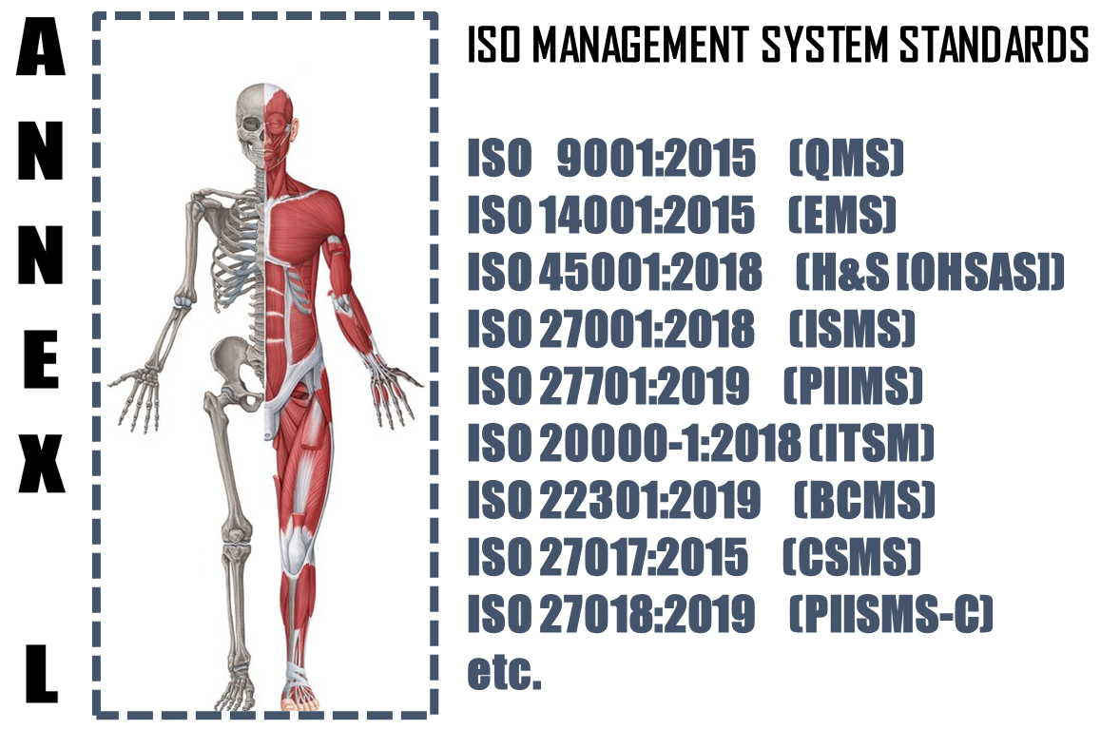

The **Annex L** (now renamed as Annex L in the 2019th edition from Annex SL) is a section of the ISO/IEC Directives part 1 that prescribes how ISO Management System Standard (MSS) standards should be written. The aim of Annex L is to enhance the consistency and alignment of MSS by providing a unifying and agreed-upon high level structure, identical core text and common terms and core definitions. The aim being that all ISO Type A MSS (and B where appropriate) are aligned and the compatibility of these standards is enhanced.

So in short we can say that Annex L is the Skeleton of ISO Management Systems and all standards are now aligned as per Annex L and all the common elements terms and definitions have also been standardized. This has been done to bring in Standard in the Structure, which was not the case in the past, though the intention was the same. So we can say, out of Intent and Content of MS, Content has undergone a change, in the form of Anne L.

What To Do in Implementing Quality Management System?

Based on the Scope and Context, following activities have to be performed in logical sequence. These guidelines given below are only basic milestones and a lot of activities may have to be streamlined as per the standard, based on Scope & Context.

|  |  |  |  |  |
| --- | --- | --- | --- | --- |
| **Step #** | **Requirement of QMS** | **What needs to be done** | **In what way IRCBO can contribute** | **Tools Recommended** |
| 1 | Documentation | * Define Scope (Technical [Product/Services] and Territorial Scope (# Locations) where the MS is needed. The Org. Management decides the specific scope; * Defining the External & Interested Parties, their business relationship with Org. (in relevance to scope), Identification of critical processes, Information & Information classification); | IRCBO’s Qualified & Experienced consultants can help you in designing, defining, Implementing, monitoring and Improving the MS.  Note: Our contracts can also be associated after Certification for Maintenance of Management System through our digitized tool contributions – aim is to make any MS a plug and play for most effective Controls & Complying | IRCBO Tool Kit which includes all solutions for Implementation and backed up by IRCBO Designed Software in cloud for :   * Online training   (including  Induction for new employees, awareness & unlimited Internal Auditor Training & Qualification   * Online Internal Auditing Software |
| 2 | Implementation | * Defining, approving, sharing QMS Policy; * Assigning Responsibilities and Authorities in more transparent manner; * Participating in Risk Mechanism and approving Residual Risk and Incident investigations; * Focusing on Increasing Competency, Considering Internal Audit Findings seriously for Timely Corrective Actions in effective manner; * Maintaining good discipline in demonstrating Leadership and aiming for improvements through Management Review platforms; |
| 3 | Periodical Review | * Performing Internal Audits * Performing Management Reviews |
| 4 | Continual Improvement | * Understanding the difference between Continuous Improvement & Continual Improvement and Implementing the same. |